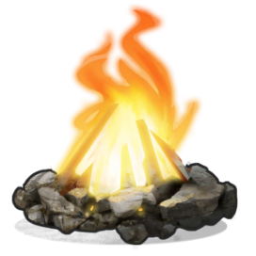

**2024 Zions Camp**

**PACKING LIST**

**Food**

* Priests- pack lunch for Tuesday (Eat on trail)
* Teachers - pack lunch for Wed. (Eat on Ferry)

**Clothing Items**

* Sleeping attire (pajamas, sweats)
* Sweater / Jacket
* Rain gear
* Hat or visor
* Comfortable tennis shoes or hiking boots
* Proper socks (3+ pairs)
* Swimsuit
* Towel
* Underwear (more than 1 pair)
* Shorts
* Long pants or sweats
* T-shirts

**Camping gear**

* Sleeping bag
* Ground cloth
* Duffel bag or packs
* Sleeping pad
* Tent or Hammock (family or ward members may share a tent)

**Toilet kit**

* Handkerchiefs
* Toothbrush / Toothpaste
* Comb
* Soap for body
* Deodorant
* Emergency TP
* Prescription medications

**Camp Necessities**

* Flashlight (extra batteries)
* Clothesline (50’ nylon cord) - Optional
* Personal First Aid kit
* Water bottle
* Washable metal or plastic cup for drink other than water
* Sunglasses
* Mosquito/Insect Repellant
* Lip balm
* Sunscreen
* Pad / Pencil
* Scriptures
* Journal
* Watch
* Collapsible camp chair

**Optional**

* Camera

**Priests**

* Camelbak or Equivalent for Hiking and Rock Climbing High Adventure (carry water and sack lunch).